Implementation of Teleconferencing System using Jini and Jiro Technology

Joanna Kosińska

Katedra Informatyki AGH, al. Mickiewicza 30, 30-059 Kraków, kosinska@agh.edu.pl

Abstract. This article takes up the problem of management of multimedia conferences in computer networks. The presented solution is based on Sun Microsystems Technologies. These technologies are: Java programming language, Jini/Jiro as a distributed environment and management platform and JMF as a interface for incorporating time-based media. The described system has been designed in Distributed Systems Research Group, Computer Science Department, AGH.

Key words. Jiro, Jini, Multimedia environments, Management platform.

- INTRODUCTION

The multimedia applications still represent important area of system research that addresses increasing demand for expanded functionality, higher quality, portability and flexibility. These requirements meet with common acceptance of new paradigms of distributed computer systems design and implementation built around distributed services and thin clients dynamically loadable on demand.

Multimedia systems of today are collections of devices and software that are complex to configure, maintain and expand. Sun's Jini promotes itself as a solution to these problems simplifying the task of building, administering and altering a network of multimedia devices, software and users. The Jini technology infrastructure provides mechanisms for components to join and detach from the network what makes the system more dynamic [7].

After creation of such systems one cannot forget to maintain them and also to monitor the systems operation. To ensure consistency of the running system, especially when its architecture is complex, reasonable is to add logging, event notification, scheduling and security mechanisms. Jini being an environment of distributed services has been extended with platform that simplified operation of those services. This platform - Jiro Technology provides services that automate the management process.

This paper presents a multimedia Teleconferencing System that is based on Java Technologies, mainly Java Media Framework, Jini and Jiro. What it leverages from Java language is its portability that makes the system appropriate for versatile usage from Personal Computers to pocket devices as iPAQ, PDA.
The spontaneously created multimedia Teleconferencing system has been based around Jini's key concepts. The system has been integrated using Lookup Service, which in conjunction with Jiro Base Services simplifies the system control and management. Widely applied leasing techniques provide a means of freeing unused or unneeded resources. Also requirements on client side are reduced to having just a browser that enables downloading the software for holding conferences.

The structure of the paper is as follows. Section 2 is an introduction to Sun's Jini Technology - new concept of networking in distributed environments. It also provides management aspects introduced by Jiro. In section 3 the system architecture of the Teleconferencing System has been presented. Section 4 concentrates on the system's operation. Next in section 5, the implementation tasks has been analyzed. The paper ends with conclusions.

- Technology support for portable Teleconferencing Systems

The distributed systems environments provide significant convenience in software creation freeing developers from cases concerned proper communication. Jini Technology is one of the newest distributed computing issues. Its solution focuses on the way distributed components are connected and may communicate together. The Jini system is a Java-centric system on the network, assuming and requiring that the communication between the clients and a service are accomplished through a Java interface.

Jini passes over the problem of rigidity once deployed. Putting some changes into services functionality does not require simultaneous updates on each client-side. The client is no longer stub's owner, if it wants to use a stub, in Jini known as proxy, it dynamically downloads it from the service through the agency of a Lookup Service.

Jini's foundations are based on five key concepts that give new techniques used in scalable distributed systems. These concepts - discovery protocols, lookup service, leasing, remote events and transactions - ensures spontaneous creation, self-healing, reliability. A short description of those that are significant to Teleconferencing System is run below.

Discovery is the process of finding, joining and looking up components on the network. This process governs the acquisition of references to lookup services. As a result of discovery the entity handles a couple of references to the lookup services for the requested djinn. Using these references, the entity is able to determine what services are available in the community [6].

Undoubtedly the most fundamental of Jini services is Lookup Service [5]. It is a service for registering other services, discovering and locating them. The most valuable novelty, compared with already known distributed systems implementations, is the manner in which clients interact with the Lookup Service without knowing location of execution. Services are stored within it as a collection of service items. Each item contains a proxy object that is an entry point to the service, and a set of attributes that in crude words describe the service.

Every distributed system needs to deal with components that cease to respond. There must be mechanisms for detecting this problem and freeing up any resources these components have consumed. Distributed resource management is performed through the use of Lease. A felicitous comparison might be a statement that lease mechanism is like distributed garbage collection.

Remote Event paradigm enables asynchronous notification of components changes. The set of interfaces and protocols allow objects in different JVMs to detect state changes, and notifying all registered entities when those changes occurs.

Jiro is a technology-based implementation of Federated Management Architecture. Its infrastructure is based on 3-tier generic model as depicted on figure 1.

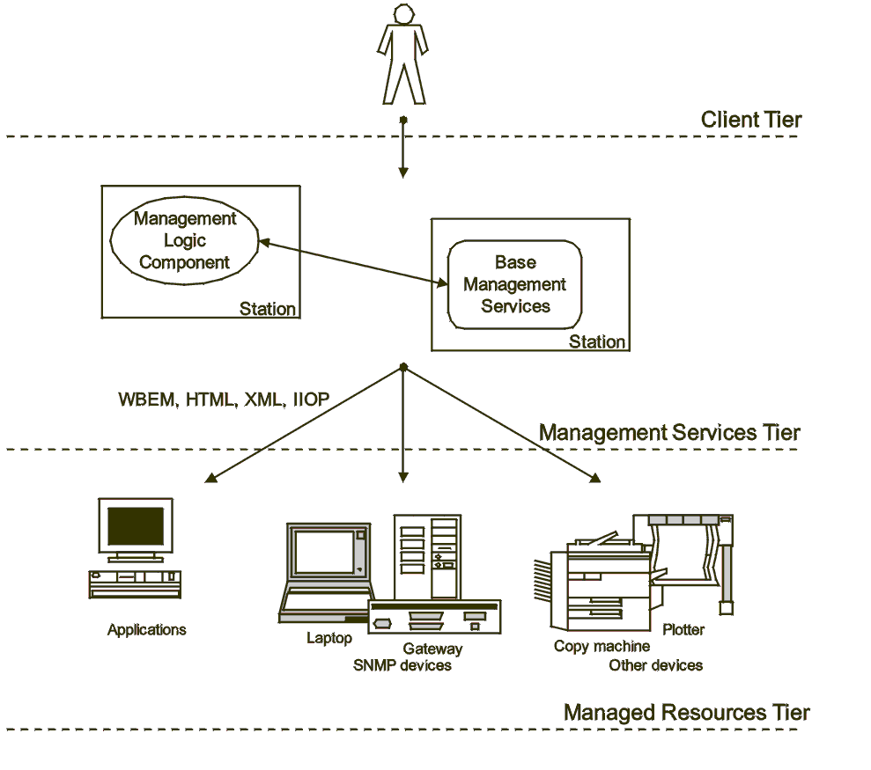
Figure 1 Architecture of Jiro Technology based on [4]

Most important is the second Management Services Tier that consists of Jini Technology services hosted by management servers. Those services are management logic components responsible for interacting, manipulating, monitoring and managing heterogeneous resources existing in third tier. Base Services are those that are defined by Jiro Technology. To those belong Event Service (based on Jini's remote event concept), Logging Service (centralized solution enabling distributed components log and audit deemed interesting information), Scheduling Service (functionality is similar to crond/crontab) and Security Service (built upon Java Authentication and Authorization Service) [4].

The dynamic aspects of Jini solutions makes it an appropriate environment for Teleconferencing Systems in conjunction with Jiro Services provides a platform that automates management and simplifies data processing.

- Architecture overview

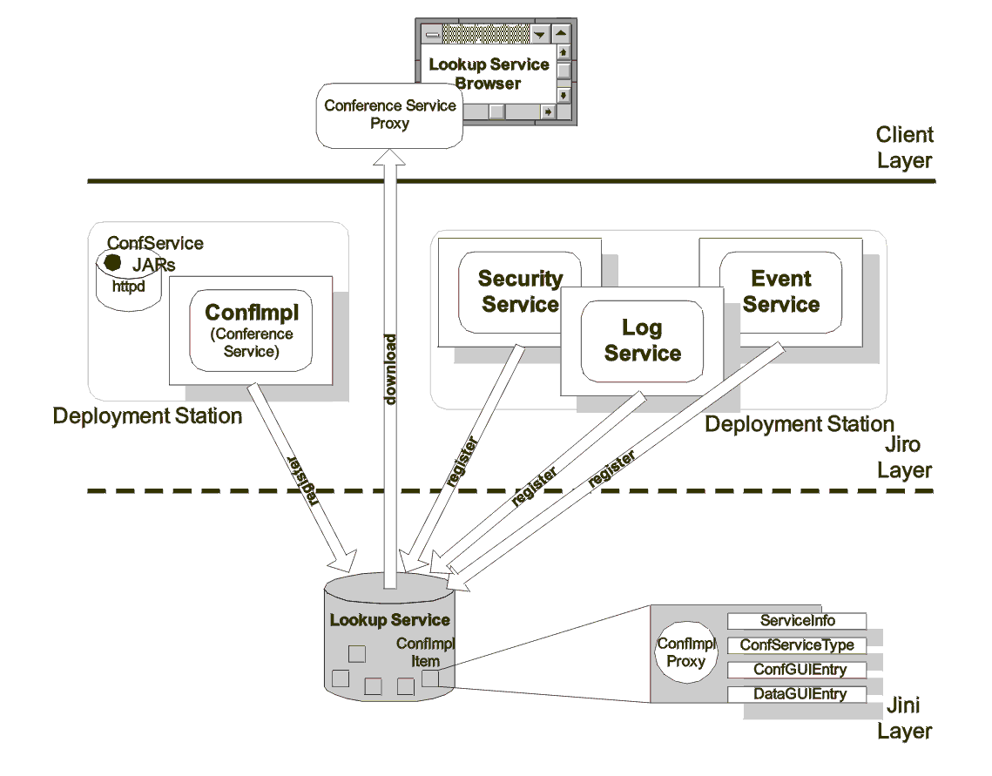
The proposed decomposition of the Teleconferencing System into layers ensures full access to services that meet client's requirements.
Figure 2 Teleconferencing System Architecture

The lowest layer - Jini Layer - is the foundation of ConfSys. It determines the environmental properties, imposes communication schemes and introduces specific dynamic extensible network behaviors. It is comprised of dynamic services (among which Conference Service is found) and collecting those services Lookup Service. The next layer - Jiro Layer - deals with Jiro-specific components. These components introduce integrated and automated management concepts into control path operations. The Teleconferencing System leverages from this layer's station concept especially the DSM (Dynamic Services Model) functionality. The Lookup Service gathers and orders also the Jiro components, hence making them easily accessible to upper layer. It is worth noticing that the boundary between the lowest two layers is blurred. In fact Jiro is an extension of Jini Technology, the components in Jiro layer are also Jini services and hence may be treated as the first layer components. The highest layer enables consumers to get, by the agency of Lookup Service Browser, ConfSys proxy and through it use the service.
The main system components are:
- ConfImpl - Main object in Teleconferencing System. During the system's life cycle there is only one object of this type existing in a given management domain. This is a centralized point in the system that ensures system consistency, most tasks are firstly processed by this object, hence it has a knowledge of Teleconferencing System state.
- Jiro Base Services - used for achieving conference specific requirements.
- Lookup Service - An entry point to the system. It holds references to all available services.
- Lookup Service Browser - component that allows viewing the lookup services. From the client's perspective it would be the means of getting the ConfSys proxy object.

- System Activity Specification

The information flow between Teleconferencing System components in the previously
described architecture is shown in the UML sequence diagram – Figure 3.
Figure 3 The usage of Teleconferencing System
: Client1
Lookup Service
ConfImpl
SecurityService
LogService
EventService
: Client2
1: getConfSysProxy
2: authenticateToSystem
3: authenticate(Client1)
4: save_log(LOGIN)
5: logSvcChanged
6: post(LogEvent)
7: notify
8: notify
9: post(ConfEvent)
10: notify
11: holdConf
12: post(ConfEvent)
13: notify
14: holdConf
15: save_log(HOLD_START)

The diagram shows a sequence of operations' invocation when a new client wants to be active in a Teleconferencing System. The client does not have installed any ConfSys components. The assumptions are that each client dynamically downloads any necessary code. To do this it only needs a lookup service browser (see next subsection) that gives him a list of all available services. The first operation downloads from the Lookup Service a ConfSys proxy that acts as a stub code for ConfImpl object. The stub enables to log into Teleconferencing System (firstly authenticate, and then inform all users of the new participant). The Log Service is an indispensable feature, enabling effective functioning and efficient event tracking. All important events are logged and may be searched when necessary. To increase the clarity log messages have been categorized to: INIT (ConfSys), LOGIN LOGOUT SUSPEND (user), HOLD_START HOLD_STOP (conference). Each client may also declare its interest in being
notified about particular events, e.g. appearance of new users, invitation to conference, etc. Jiro Event Service brings to Teleconferencing System a novelty of communication schemes based on Event Service interaction patterns. The implementation of events distribution is based on publish-subscribe pattern as the one ensuring scalability.

4. 1 Lookup Service Browser

A lookup service browser is a useful component, allowing viewing the lookup services in the system. It gathers all the information associated with services and displays them in a compact, user-friendly form. Thus, it allows users for a fast orientation in the system's state, making a control decisions and managing the system. Such a browser facilitates searching for services implementing specific interfaces, having associated desired attributes, existing in particular lookup services, etc. Perhaps more importantly, it provides means for running services, even those with unknown interfaces. Well-behaved multimedia services attach to their proxies set of describing them information, called attributes. One of the attribute could be an icon which represents particular service, clicking on which might open it up to display its GUI.

- implementation issues

An important feature of created system was ease of creation with Jini/Jiro technology. Comparatively simple object language as Java is, used while implementing Teleconferencing System, and rich tool set supporting software creation even more appeals for this system. Apart from convenience of programming, important is accessibility and completeness of documentation provided by Sun Microsystems.

Besides obvious advantages brought by Jiro Technology usage, worth noticing is fact that this is a quite new technology. Its deployment was preceded with release that was not precisely tested, though contains lots of bugs and sometimes weakness of solution as is in case of Security Service. Therefore the authentication and authorization issues should be implemented using e.g. LDAP tools rather those provided with Jiro.

Apart from exploiting Jini/Jiro Technologies the Teleconferencing System uses Java Media Framework (JMF) as the mean enabling transmitting and receiving multimedia streams. JMF takes care about proper stream decoding, and provides basic display controls simplifying the burden of programming issues. JMFs biggest advantage is the ability of playing streams starting from any point of the stream [10], what is important especially in conference environments.
Apart from beneficial properties, JMF has also its downside. The nature of much multimedia computation requires the use of native methods. The biggest problem is that certain multimedia formats require codecs for rendering that need to be implemented (for now) using native methods; sometimes the native methods are actually implemented in the host machine language that often does not result in a cross platform fashion. There is yet a portable version of JMF, but firstly it would be recommended to make some performance test with it.

- Conclusions

This paper investigated the usage of Jini/Jiro technologies to built distributed systems for managing and holding multimedia conferences. All Jini's features help to overcome inherent complexity of the multimedia systems control and management. The defined mechanisms provide resilience in a dynamic networked multimedia environment. The system benefits from exploiting the Java environment with its portable source code, dynamic downloading, and polymorph object-oriented properties.

Although the basic functionality of the system has been described, new challenging problems open up opportunities for research. Very interesting and important problems cursorily addresses in this paper concern security in the system, access control functions with authentication and identification. As Jini/Jiro is a quite innovative technology it needs lot of performance, scalability, portability testing. Its dynamic spread and development would solve in future the unique set of multimedia environments' problems.

ImplementaCJA Systemu teleconferencyjnego przy użyciu technologii jini oraz jiro

Streszczenie. Niniejszy artykuł podejmuje problem zarządzania konferencjami multimedialnymi w sieci komputerowej. Przedstawia propozycję jego rozwiązania w oparciu o technologie dostarczone przez Sun Microsystems. Tymi technologiami są: język Java, Jini/Jiro jako środowiska rozproszone i zarządzające oraz JMF jako narzędzie odpowiedzialne za przetwarzanie strumienia multimedialnego. Opisany system multimedialny został zrealizowany w Zespole Systemów Rozproszonych Katedry Informatyki AGH.

Słowa kluczowe. Jiro, Jini, Środowiska multimedialne, Platforma zarządzająca.

LITERATURE

[1] Sun Microsystems.: Federated Management Architecture Specification. Sun Microsystems, Revision 0.4, 1999.
[2] Sun Microsystems,: Jiro Technology Installation and Configuration Guide. Sun Microsystems, 2000
[3] Sun Microsystems,: Jiro Technology SDK Programmer’s
Guide. Sun Microsystems, 2000
[4] Sun Microsystems,: What is Jiro Technology? Series I, Part I. Jay Miller, Kelby Zorgdrager.
[5] W. Keith Edwards,: Core Jini. The Sun Microsystems Press, 1999
[6] Sun Microsystems.: Jini(TM) Architectural Overview. Sun Microsystems, Technical White Paper.
[7] Sun Microsystems,: Why Jini Technology Now? January 1999
[8] Joanna Chlebek,: Jiro based Multimedia Conference System design and implementation, Msc Thesis Work, June 2001
[9] Service Finder, http://www.okilab.com/jini/finder
[10] Java Media Framework API 2.0 API Guide

